About the Electricity Market Simulation Game (EMSG)
An interactive tool for understanding electricity markets

_____________________________

Welcome to the EMSG!
Are you ready to trade electricity in the market?
_____________________________

The Electricity Market Simulation Game (EMSG) is an interactive, web-based learning tool that designed to help participants understand how competitive electricity markets operate in practice. Through a realistic market simulation, players take on the role of electricity market participants and make decisions under conditions similar to those faced by generators, traders, utilities, system operators and large electricity consumers.
Rather than learning market concepts through theory alone, participants experience first-hand how electricity is bought and sold, how prices are formed, and how market participants respond to uncertainty and changing system conditions.

How the EMSG works
During the simulation, participants:
- Submit bids and offers into the Day-Ahead Market
- Adjust their positions in the Intraday Market
- Respond to changing market conditions and unforeseen events
- Manage generation outages, weather impacts and forecast deviations
- Balance commercial objectives with operational constraints
- Minimise imbalance costs while maximising financial performance

Each decision influences market outcomes, allowing participants to observe how individual actions collectively shape electricity prices, system balancing requirements and market efficiency.

Learning Objectives

The EMSG provides a practical introduction to key concepts of electricity markets, including:
- Electricity market design and operation
- Price formation and market signals
- Day-Ahead and Intraday trading
- Balancing and settlement mechanisms
- Risk management and trading strategies
- System flexibility and security of supply
- Market participant behaviour and incentives

The simulation is particularly valuable for professionals working in electricity regulation, system operation, market operation, policy-making, utility management, academia and the broader energy sector.

Supporting South Africa's Energy Transition

South Africa is undergoing a significant transformation of its electricity sector, including the establishment of a competitive electricity market. The EMSG was developed to support capacity development and stakeholder preparedness for this transition by providing an accessible and engaging environment in which participants can explore market mechanisms and understand their practical implications.
By combining experiential learning with realistic market scenarios, the simulation helps bridge the gap between market theory and real-world application.

Development and Partners

The EMSG was developed in 2025 by Fastbreak.One under the South African-German Energy Programme (SAGEN) | Capacities for the Energy Transition and in close collaboration with the National Transmission Company South Africa (NTCSA) and the Power Futures Lab (PFL) at the University of Cape Town Graduate School of Business.

SAGEN is implemented by Deutsche Gesellschaft für Internationale Zusammenarbeit (GIZ) GmbH on behalf of the Federal Ministry for Economic Development and Cooperation (BMZ).

The EMSG forms part of broader efforts to strengthen technical, regulatory and institutional capacities required for South Africa's evolving electricity market landscape.

Funded by
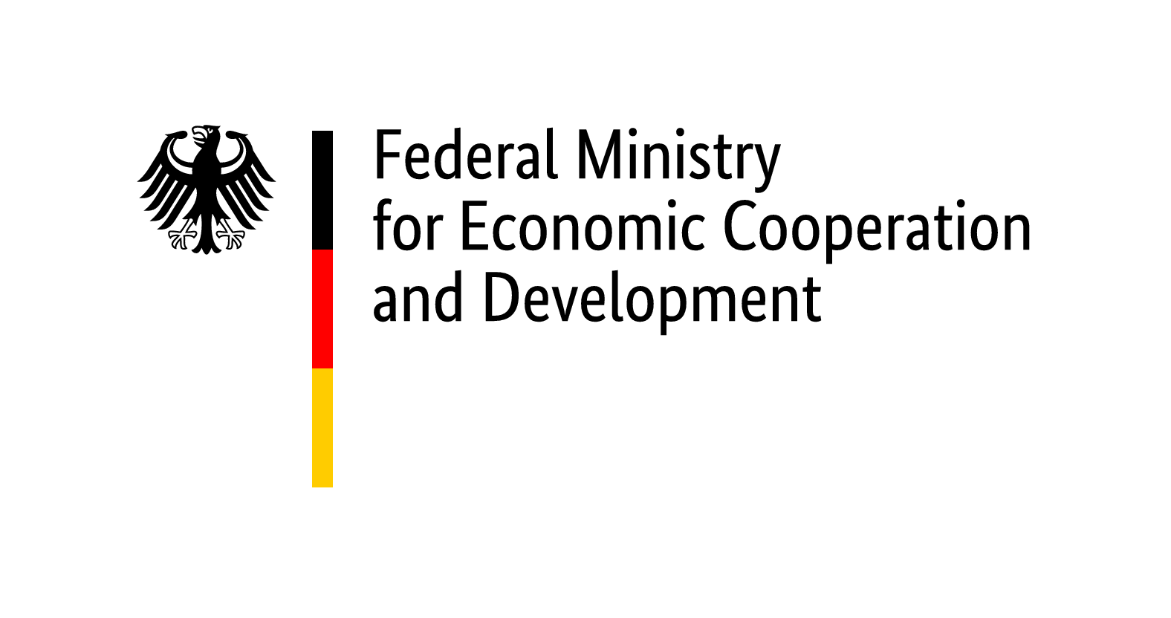

Implemented by  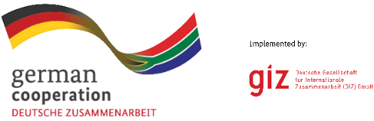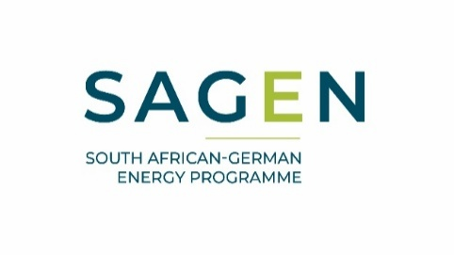 | In collaboration with  

Developed by



